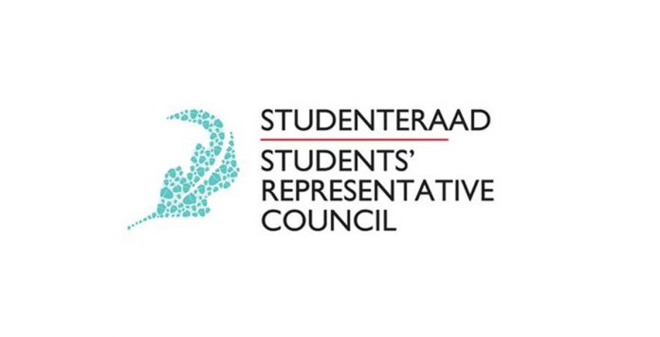

Vision:
We, the Student Representative Council of Stellenbosch University, envision a welcoming and enabling environment where students can holistically develop as active participants in an integrated, universally accessible and safe community.

Mission:
Our mission is to champion student success by creating accessible platforms for open dialogue and collaboration with students; to serve and represent all students’ needs across our campuses and the platforms we serve on, through recognition of the diverse nature of the student body and promoting students’ rights.

NAME | POSITION | EMAIL | CONTACT
SRC MEMBERS
Lewis Mboko | Chairperson | lewis@sun.ac.za | 0619359117
Wamahlubi Ngoma | Vice Chair | wamahlubi@sun.ac.za | 0711436806
Brandon Murray | Treasurer | brandon7@sun.ac.za | 0723898085
Fadeelah Williams | Secretary General | fadeelah@sun.ac.za | 0798120053
Jeff Ngobeni | Transformation | jeffngobeni@sun.ac.za | 0796151399
Lwazi Phakade | Communications | 18194796@sun.ac.za | 0738621698
Sifiso Zungu | Leadership & development | zungus@sun.ac.za | 0731830039
Jonathan Stokes | Policy Officer | 18622453@sun.ac.za | 0656866451
Chloe Krieger | Student Wellness | chloek@sun.ac.za | 0823339532
Thembakazi Swartbooi | MILAC Student Captain | 22471170@sun.ac.za | 0762879716
Ntsako Mtileni | TSRC Chair | tsrchair@sun.ac.za | 0823908681
Xola Njengele | AAC Chair | xn@sun.ac.za | 0729527797
Yanga Keva | SC Chair | yanga@sun.ac.za | 0748136981
Tebogo Ndaba | SPC Chair | ndaba@sun.ac.za | 0827218065
Ingrid Heydrenrych | PC Chair | ingridh@sun.ac.za | 0725500100
Michael Burke | Vice PC Chair | burke@sun.ac.za | 0727930629

NAME | POSITION | EMAIL | CONTACT
SRC MANAGERS
Eric Le Roux | Sport | 21583439@sun.ac.za | 0766316210
Robynne Boonzaaier | Brand and Marketing | 20724853@sun.ac.z | 0617482042
Christina Brazier | Safety and Security | 21816891@sun.ac.za | 0712798817
Shilela Bopape | Sustainability | 19212453@sun.ac.za | 0722239416
Joconde Nsumbu | SU International | 20361785@sun.ac.za | 0843928969
Grace Mngadi | Womxn and Queer empowerment | 22671439@sun.ac.za | 0739487772
Philip Visage | Arts and Culture | 21591253@sun.ac.za | 0763149043
Luigia Nicholas | Special Needs | 18342078@sun.ac.za | 0718737042

NAME | POSITION | EMAIL | CONTACT
ELECTION CONVENORS
Maxwell Mlangeni | Election Convenor | 19120893@sun.ac.za | 0799548532
Lesedi Motumi | Election Convenor | 22577629@sun.ac.za | 0764695648

NAME | POSITION | EMAIL | CONTACT
DISCIPLINARY COMMITTEE
Wamahlubi Ngoma | Chairperson | wamahlubi@sun.ac.za | 0711436806
Jimmy Lefika | member | 23267240@sun.ac.za | 0738896501
Marietjie Booyens | member | 17596754@sun.ac.z | 0728425291
Thimna Sotyatyo | member | 21717265@sun.ac.za | 0744907501
Luigia Nicholas | Special Needs | 18342078@sun.ac.za | 0718737042

NAME | POSITION | EMAIL | CONTACT
SRC RESIGNATIONS
Jonathan Stokes | Policy Officer | 18622453@sun.ac.za | 0656866451

